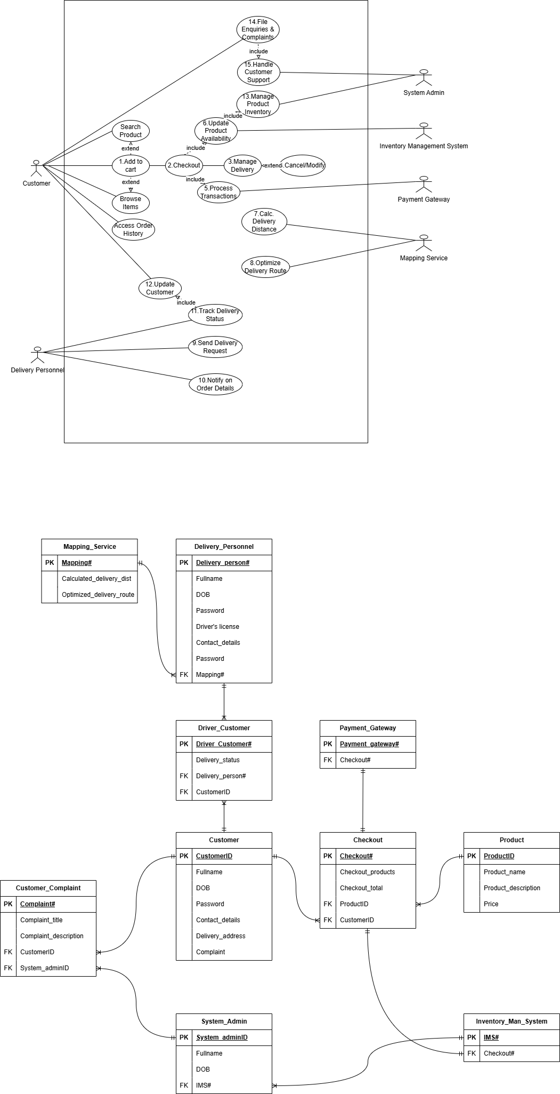
Figure 1: Use Case Diagram & Physical Entity Relation Diagram

